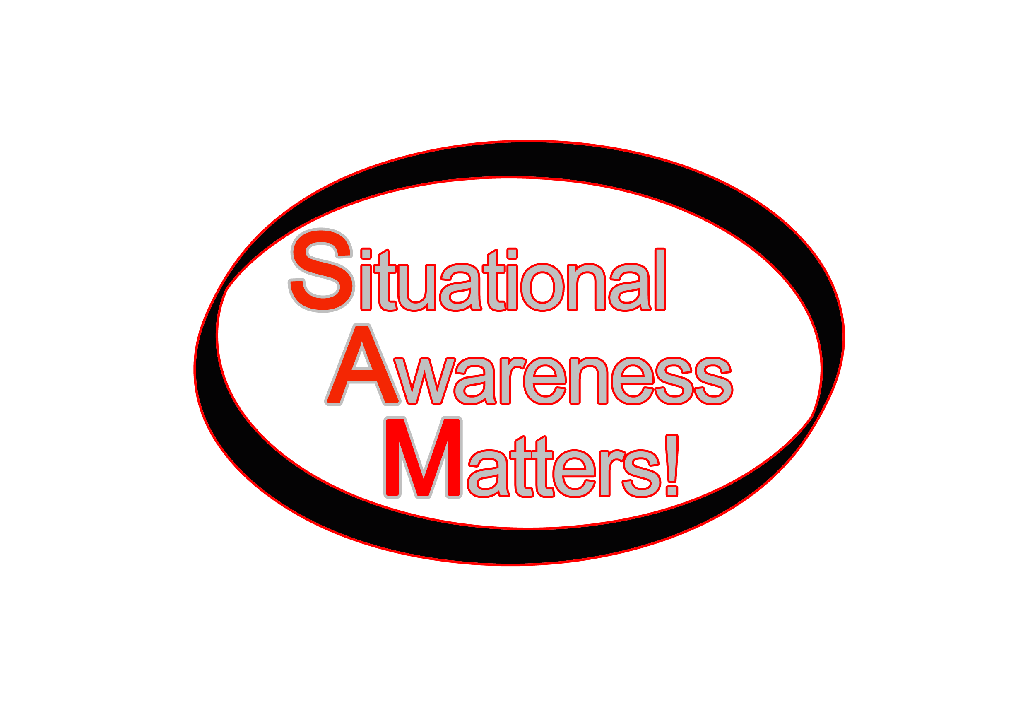

Situational Awareness
“Lightening Round”

30 Situational Awareness Barriers

Presented at:
Fire Department Instructor’s Conference
Indianapolis, Indiana
April 20, 2014

Presented by:
Dr. Richard B. Gasaway
Situational Awareness Matters!
St. Paul, Minnesota
www.SAMatters.com

Situational awareness

Your ability to perceive AND understand what is happening in your environment and then, in turn, be able to accurately predict future events… in time to avoid bad outcomes.

Flawed Situational Awareness is never the root cause of a casualty or near-miss. It’s a symptom. Barriers that flaw situational awareness are the root cause.

Barriers

There are over 100 barriers that can flaw situational awareness. This program is an introduction to 30 barriers.

- Pre-Arrival Lens
- Confirmation Bias
- Stress-induced narrowing of sensory input
- Task Fixation
- Task Saturation
- Multitasking
- Mission Myopia
- Urgency
- Time Distortion
- Over Confidence
- Complacency
- Fear
- Peer Pressure, Supervisor Pressure, Cultural Influence
- Bad Habits, Unconscious Incompetence
- Wishful Thinking, Optimism & Denial
- Overwhelm
- Complexity
- Short-Term Memory Overload
- Confabulation
- Auditory Exclusion
- Stress Induced Blindness, Motion-Induced Blindness
- Hallucinations
- Change Blindness
- Flawed Perceptions
- Lack of Shared Mental Models
- Distractions
- Miscommunications
- Flawed Expectations (Overconfidence in Crew Ability)
- Failure to understand negative clues & cues
- Hindsight Bias

Gasaway Consulting Group, LLC All Rights Reserved. No part of this document may be reproduced or transmitted in any form by any means, electronic or mechanical, including photocopy, recording, or any information storage and retrieval system, without permission in writing from the author.

The contents of Flawed Situational Awareness, Fifty Ways to Kill A First Responder and Mental Management of Emergencies are the intellectual property of:

Richard B. Gasaway, Ph.D.
Gasaway Consulting Group, LLC
1769 Lexington Avenue North, Suite 177
St. Paul, Minnesota 5113-6522

If you are interested in hosting a program, please contact Carol@RichGasaway.com or 612-548-4424

